Hostel Keeping

Friday, August 5, 2022 12:30 PM

LOGIN PAGE

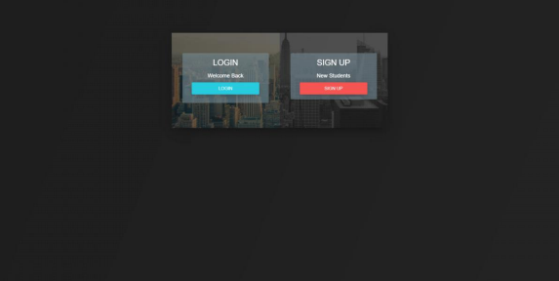STUDENT LEVEL OR ADMIN LEVEL LOGIN:

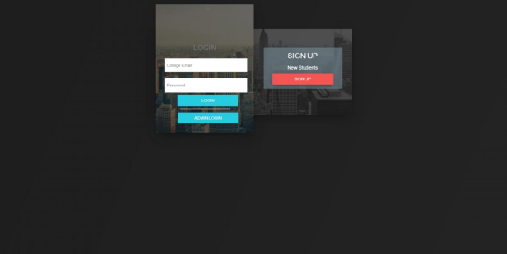ADMIN LOGIN:

New Section 1 Page 1

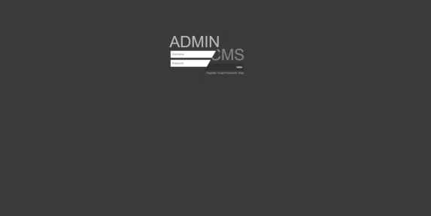

SIGN UP:

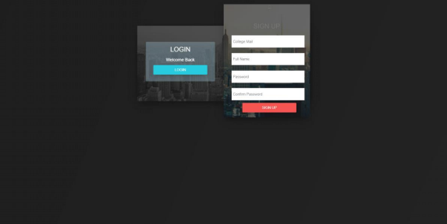

STUDENT DASHBOARD AFTER LOGIN:

DASHBOARD:

New Section 1 Page 2

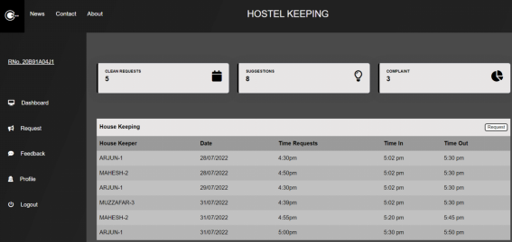

News:

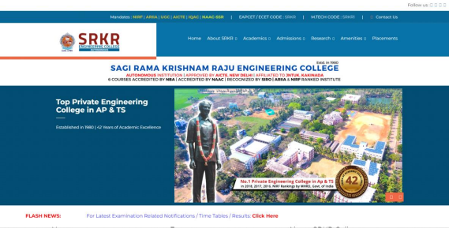CONTACT:

New Section 1 Page 3

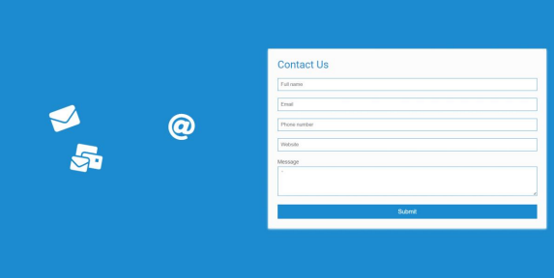ABOUT:

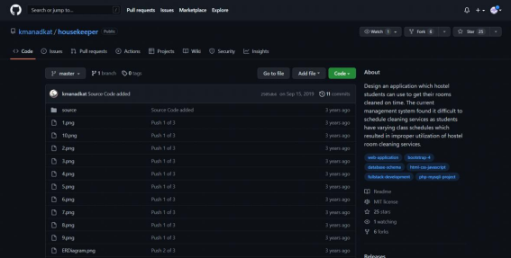FEEDBACK:

New Section 1 Page 4

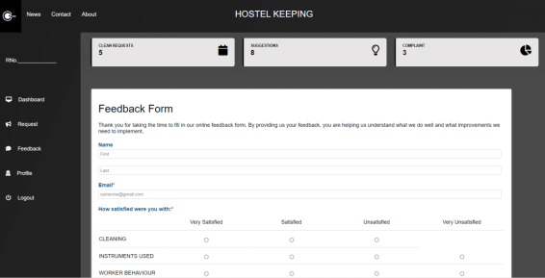

PROFILE:

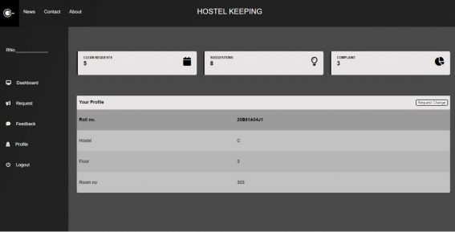ADMIN LEVEL DASHBOARD:

New Section 1 Page 5

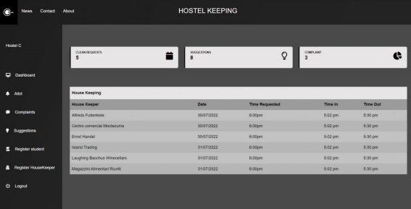

TOTAL LOGIC MAP BEHIND THE PROJECT:

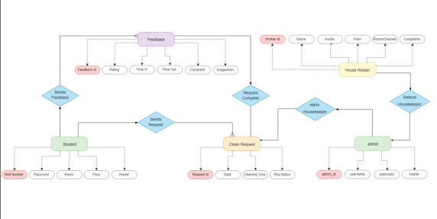FOR LOGIN:

New Section 1 Page 6

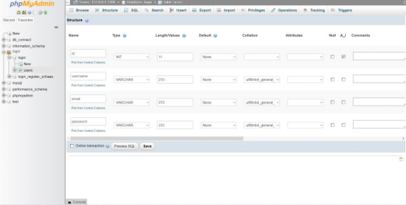 New Section 1 Page 7